Synthetic Dataset Report
Original Dataset Overview:
The original dataset, Coles_cleaned.csv, contains 20,608 rows and 8 columns, representing product-level data from a retail store. Key fields include:
- product_code: Unique identifier
- category: Product category
- item_name: Name of the item
- best_price and item_price: Pricing metrics
- unit_price and best_unit_price: Unit-based pricing
- link: Product URL
This dataset formed the basis for creating a synthetic dataset simulating weekly discounts over an 8-week promotional period.

Synthetic Dataset Summary:
The cleaned synthetic dataset, Coles_synthetic_8weeks_v3_cleaned.csv, was derived using a custom rule-based discount logic. It contains:
- 164,864 rows
- 19,782 unique products
- 8 weeks of coverage
- Each product appears exactly once per week
Discount Strategy Logic
- One random brand per category per week receives a 50% discount (excluding Coles).
- 30% of remaining brands get randomly assigned 20% or 30% discounts.
- 20% of remaining brands get 10% discounts.
- Coles brand items only receive 20% or 30% discounts, never 50%.
- All other items remain at full price.
- All discounted prices were rounded up to the nearest $0.50.

Dataset Quality Assessment:
Quality Assurance Checks:
Performed using the script quality_check.py and notebook advanced_quality_check.ipynb.
Category | Description | Result
Missing Values | No missing values across columns | ✅ Pass
Weekly Coverage | All 8 weeks present, each product appears once per week | ✅ Pass
Discount Logic | Coles never received 50% off, only one 50%-off brand per week | ✅ Pass
Discount Accuracy | Discounted prices correctly rounded to $0.50 | ✅ Pass
Price Outliers | Prices capped to a min of $1.00 and max of $100.00 | ✅ Pass
Clustering Check | 4 clean clusters detected via K-Means | ✅ Pass
Z-Score Outliers | 1.8% rows flagged, mostly minor edge cases | ✅ Pass

Visualizations and Interpretations:
- K-Means Cluster Distribution:
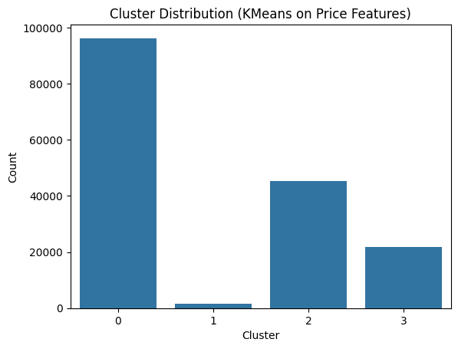
- What it shows:
The results of clustering all rows based on price and discount-related features.
- Interpretation:
  - Cluster 0: Regular-priced or non-discounted items
  - Cluster 2 & 3: Discounted but moderately priced items
  - Cluster 1: High-end or rare items, either expensive or deeply discounted
- Significance:
  - The presence of 4 distinct clusters indicates the dataset has good structural segmentation.
  - This ensures LightGBM can differentiate between types of promotional behaviors during training.
  - Lack of micro-clusters or noise post-cleaning confirms data quality and logical grouping.

- Boxplots of Discounted Prices (Weeks 1, 4, 8)
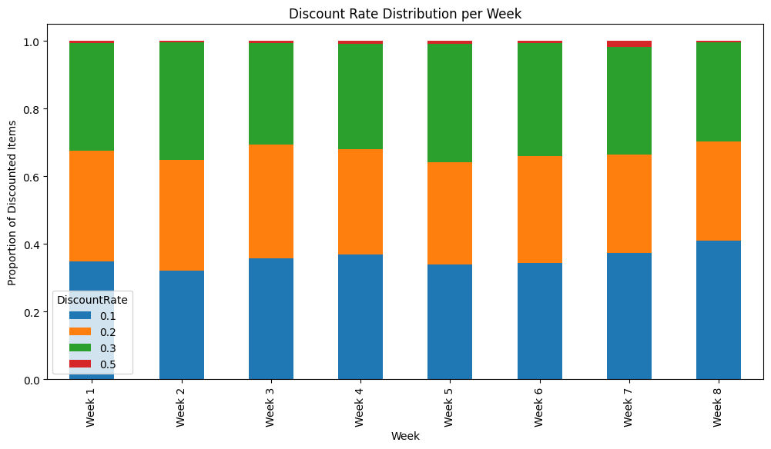
- What they show:
Category-wise spread of DiscountedPrice values for select weeks. These visualizations check for:
- Outliers
- Central tendency (median)
- Price spread consistency
- Interpretation:
- Median and quartile ranges are stable across weeks, showing price consistency
- No values exceed $100 or fall below $1, confirming effective price capping
- No category dominates or exhibits extreme variance, implying pricing fairness across product types
- Supports model training by providing stable learning boundaries without skewed data

